Minute of meeting of Strathard Community Council held on Thursday 3rd 2023 in Kinlochard Village Hall. Hybrid meeting access via Teams.

Present: Paul Mackintosh (Chair), Nick Lester-Davis (Vice-Chair), Catherine Cairns (Treasurer), Joyce Kelly (Planning rep), Trevor Geraghty (SCT rep), Clare Graham, Natashya Sheppard, Ward Cllr Gene Maxwell, 2 members of public

Minute taker: Kate Bovill (SCT Development Officer)

Apologies: Police, Gillian McEwan, Lynda McColl

Paul Mackintosh (PM) welcomed the newly elected councillors
Minutes of last SCC meeting 22/06/23 - proposed Nick Lester-Davis (NLD) seconded Joyce Kelly (JK)

Chair welcomes all to the meeting and thanks councillors for attending the Gala as well as extending thanks to the organisers of the event. There is a new format to SCC meetings with a focussed topic for meetings. Councillors are requested to ensure all business areas are updated by email in advance to ensure effective discussion within meeting time.
Matters arising | Comms - Trevor Geraghty (TG) raised EE emergency mast provision directly with SC Sean Marley. SC need to take this up directly with EE. He raised the blackspot issue and suggested that this could be addressed by FLS installing Starlink at the Loch Chon Campsite. Broadway broadband are in administration.  Hub Renewal - TG suggests that the £120 (off peak unlimited) membership fee would be most appropriate and could be reviewed if SCC used Hub to a greater extent than anticipated. Councillors agreed unanimously to take this Hub membership plan | No action clarified re FLS suggestion  Catherine Cairns (CC)  to action Hub payment
Resilience | Focus topic for the evenings meeting. The Resilience Plan Report from SCT had been sent for councillors information questions prior to the meeting. Discussion around the term resilience - agreement that what SC mean as a ‘Resilience Plan’ is an Emergency Response Plan and that SC should be responsible for a Resilience Strategy for Strathard. NLD & Kate Bovill (KB) clarified that what SCT had worked on is around developing emergency response within the community in advance of emergency help arriving. Councillors recognised the value of having an emergency response plan. TG commended the work done by KB and agreed that SCC should adopt an emergency response (ie the SCT produced ‘Resilience’) plan and the simple, practical actions it includes. Much discussion was held around the broader topics impacting on the community resilience as well as risk/emergency access & resource. Clare Graham suggested breaking it into immediate, medium and longer term actions re emergency resilience and that it could be focussed on specific scenarios (eg flood/power outage) TG suggested an annual meeting for the community around how to prepare for emergencies and having the document available online. PM requests Councillors to look at the document and comment. CG produced an online form to share comments on the plan in order to progress SCC aims of an effective emergency response plan for Strathard Communities. | SCC to comment on SCT Resilience Plan Report  SCC to take up the need for a broader Resilience Strategy to be taken forward by Stirling Council
Treasurers Report | Only change has been £125 from account. TG brought £45 from the Gala fundraising to go into Christmas event funding. TG requires cheque for Mailchimp, CG for Microsoft and Minute Secretary for fees | CC
Police Report | Appendix 1  Separate communication around a sexual assault reported to police in Strathard. Police increased patrols including mounted police and that they do not think there is a risk to the general public or that residents should change their behaviour.  Following another incident associate with the Highland Flames festival, PM emailed police directly requesting they attend the SCC meeting. They cannot attend evening meetings and have been deployed elsewhere. NS confirmed she would be happy to attend a daytime meeting to facilitate police attendence. TG questioned the visibility of any approved license for the event.
Road Safety | FW raised concerns of the speeding from the straight road past forest hills to and beyond Kinlochard. Campbells van notable speed through Aberfoyle. Much discussion around speeding. KB suggests a collaborative campaign with the school. Speeding has already been highlighted by the school in Strathard News. Clear messaging from SCC should be that all residents should report directly to the police ANY speeding incident in order to prioritize resource. Companies witnesses speeding can be contacted directly as well as reported to police. FLS/Police should be notified of any contractors speeding on forest tracks. | PM draft message for SCC approval  SCC to use fb page to promote
Flooding | SCC Flood Group have produced an in depth report around the specifics of flooding and suggested solutions.  NLD will draft a letter for SCC approval requesting Stirling Council reopen/refresh plans for flood alleviation. | NLD draft letter to SC
FLS | NLD & Working Group/Councillors to meet to discuss response to FLS letter about the forest track/resident access.  TG - SC has been refused Timber Strategic Funding, Road Condition impacted by extraction, FLS deny contractors use the B829, 2 private vehicles have come off the road in the past week and been helped by residents.  FLS CEG meeting coming up - Cllrs to report by 26/8 anything to be taken to FLS
Life Plans | LLTNP aiming to have LPP by Jan ‘24. Have agreed 2 days funding to CNN to bring the 3 approved CLP’s into one LPP.  Stronachlachar and Inversnaid Meeting at Pier cafe 15/9  Aberfoyle Steering Group have met and will feed back re terms of reference | KB to email Joyce Kelly
Planning Report | Please see attached  NS queried if SCC can object to AVC plans from FLS | JK to enquire about AVC
Trust update | SCT are putting in a note of interest about the Aberfoyle Car Park currently leased to The Scottish Wool Centre
Next Meetings of SCC  7pm Start | 7th September Aberfoyle Memorial Hall  2nd November tbc  7th December tbc

Community Council: | Trossachs and Teith Ward,  Strathard Community Council  hello@ccstrathard.org

Reporting Period: | 01/07/23 to 02/08/23 Compiled by PC Donald King

Ward Plan Priorities | Antisocial Behaviour  You are concerned about antisocial behaviour including drunken behaviour.  On the evening of the 16/07/23 an assault took place at the Inversnaid Hotel. Enquires are continuing

Road Safety
You are concerned about speeding, dangerous driving and indiscriminate parking.

On Saturday 29/07/23 Pc Deans and King were at the David Marshal Lodge with the Close Pass mat educating drivers regarding the space required to pass cyclists safely.

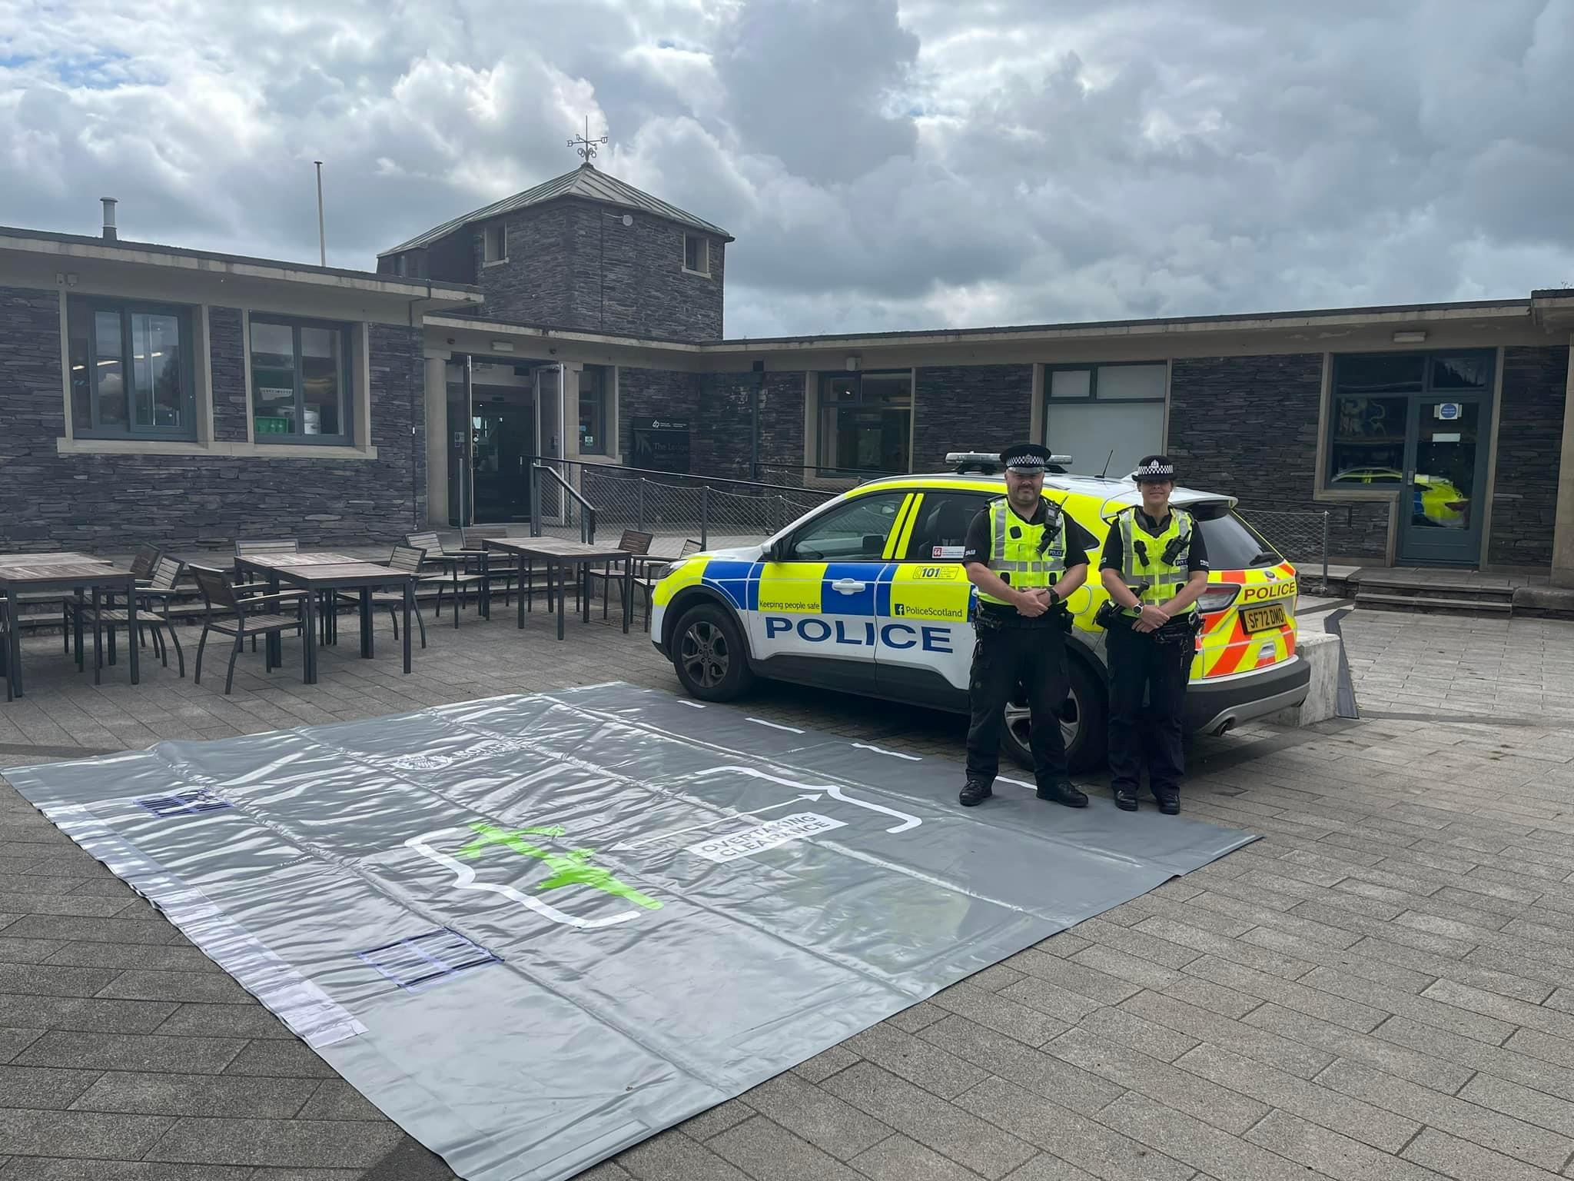

Theft
You are concerned about homes being broken into and travelling criminals.

On the 12/07/23 a shoplifting occurred at the Co-op Aberfoyle. This is linked with similar offences at other Co-op stores in the Stirling area with enquiries continuing.
On 09/07/23 a theft occurred from a hotel room at the Forest Hill’s Hotel. Enquires have been carried out and the person responsible has not been identified.
On 03/07/23 a theft of wood occurred at Forestry & Land Scotland Premises in Aberfoyle. Enquiry is ongoing.
On 02/07/23 a theft occurred at the Inversnaid Bunk House. Enquiries have been carried and to date the person responsible is unidentified.
Community Engagement and Reassurance
It is important to you to have community officers who you know, who are accessible and who address local problems.

If anyone has any policing issues that they wish to discuss, please contact us at Callander Police Office on 101 or email TrossachsTeithCPT@scotland.police.uk

Other Incidents / Activity of note

Issues raised

Community Council Feedback

The Community Officers for your area are: PC Donald King and PC Lorna Deans, based at Callander Police Office.

The Community Sergeant for the area is PS Sarah Stephenson, based at Dunblane Office.

They can be contacted via the email address TrossachsTeithCPT@scotland.police.uk or by phoning 101
We regularly publish information on the ‘Forth Valley Police’ Facebook page and tweet using @StirlingPol

