Strathard Community Council
DRAFT Minutes of the Meeting held at 7pm
on Thursday 7th March 2024 at Forest Hills Hotel, Kinlochard.
Present: | Paul Mackintosh (Chair), Nick Lester-Davis (Vice Chair), Lynda McColl (Secretary), Joyce Kelly (Planning), Trevor Geraghty (Strathard Community Trust), Catherine Cairns (Treasurer), Natashya Sheppard.
In Attendance: | Katy, Anderson, (Forestry & Land Scotland), Esther Lim (Minute Taker)
Apologies: | Gillian McEwan, Andre Goulancourt, Councillor Martin Earl, PC Lorna Deans, PC Donald King.
Residents: | 1 member of the public was in attendance.

1. | Welcome and Apologies  The Chair welcomed attendees to the meeting and gave the apologies. The meeting was recorded for the benefit of the minute taker.
2. | Approval of Previous Meeting Minutes  The unconfirmed minutes of the OGM held on 1st February 2024 were approved having been proposed by Joyce Kelly (JK) and seconded by Catherine Cairns (CC).
3. | Questions from the floor / Members of the public to be declared  A member of the public raised the issue of local road closures. Paul Mackintosh (PM) confirmed that this would be discussed later in the meeting as part of the outstanding enquiries.
4. | Translocation of Beavers – Katy Anderson, Forestry & Land Scotland (FLS)  Katy Anderson (KA) of FLS explained the proposal to translocate beavers into the Strathard area. The Scottish government recognises the of benefits of beavers for promoting biodiversity and flood management. They are looking to reduce culling and to translocate beavers to areas where there is little contact and potential conflict with other land uses. Strathard has been identified as a ‘within range area’, that is as a likely area for translocation. This is due to the native woodlands, large areas already managed by FLS and the presence of beavers already in the area. Beavers have been observed around Loch Achray and Loch Venachar since 2016 and have now spread into areas such as Loch Drunkie, Loch Katrin, Flanders Moss and Aberfoyle forest.  KA confirmed that there was no licence for translocation in place as yet, but wished to consult with the local community on this proposal.  PM asked if an increase of beavers would have any adverse effects on other animals in the landscape. KA replied that beavers are a native species and other native species would not suffer from their presence.  JK asked if beavers spread diseases like TB. KA confirmed they carry the same diseases as other rodents already present in the ecosystem, such as rats.  A member of the public asked what impact the translocation of beavers would have on the feeder burns for trout on Loch Ard. KA replied that beavers would not be sited on feeder burns and that research shows that the overall impact of beavers on fish populations is good. Lynda McColl (LM) pointed out that Loch Ard has a lot of gravel and expressed concern that the presence of beavers could impact the gravel and in turn the successful spawning of fish. LM asked KA to investigate this potential impact and report back to SCC. [Action: Katy Anderson]  Members discussed whether beavers could have an impact on flooding, currently a matter of concern in the area and asked KA what the long term plan would be for managing the impact as the beaver population increases.  KA agreed to send PM a written statement on FLS plans for the translocation of beavers and a request for community feedback. This will be added as an addendum to the meeting minutes and shared with the community. [Action: Katy Anderson and Paul Mackintosh]  A member of the public expressed concern at the spread of sea eagles which can potentially take out lambs. KA confirmed that, as yet, no sea eagles had been seen nesting locally.
5. | Priority Focus – The Big Conversation  Members expressed their dissatisfaction at the way the process of The Big Conversation was managed and the quality of the answers to enquiries. They were concerned that following the budget meeting on 29th February they were still unclear what the cuts to services would actually mean on the ground. Particular concern was expressed with respect to nursery provision. Members agreed to raise a specific enquiry to Stephen Bly regarding the impact on Aberfoyle Nursery and School. CC and JK will form a question and send it to PM who will forward the enquiry to Stirling Council (SC). [Action: Catherine Cairns, Joyce Kelly, Paul Mackintosh]  Members agreed to ask the school if there is anything SCC can do to support them or if there are any issues on which they want clarification from Stirling Council (SC). CC will raise this at the next parent council. [Action: Catherine Cairns]  As part of The Big Conversation, SCC led a rural CC forum to discuss The Big Conversation and its impact on rural CCs. Members discussed whether this forum should continue. They agreed that PM would schedule an update meeting for CCs and ask them if they want to continue the forum targeting specific issues going forward. [Action: Paul Mackintosh]
6. | Summary of Ongoing Business / Enquiries Raised
 | 6.1 | B892 Milton – Speed Restrictions  At the last SCC meeting, residents in Milton asked for the speed limit reduction to 40mph to be extended. Following an enquiry raised by SCC, SC explained that the process to extend the 40mph limit began in 2016 but was not progressed due to objections. The matter was raised again in 2021 but was not progressed due to inadequate support from SCC. Given the previous history SC are unwilling to proceed without the full support of all members of SCC.  SC also pointed out that there is not enough space at the side of the road to put up adequate speed signage and concluded that the proposed 40mph area would need to extended to facilitate adequate signage. Sorry, I didn’t catch where it would be extended to. Some members disagreed this on this point and there was considerable discussion about where signs could be erected. There was considerable discussion around safety concerns, speeding and the efficacy of speed limits and signage. Members discussed community speed monitoring and PM drew their attention to the Speedwatch information supplied alongside this month’s police report.  PM expressed his discomfort that SCC had been asked by SC to respond on behalf of the community following an enquiry raised by one individual. Members discussed at length the validity of putting out a survey to the community or making a decision on their behalf. Members agreed to respond to SC with 2 questions: 1) What other speed reduction measures can they put in place? 2) Why can’t they put up when there is space further up the road? [Action: Paul Mackintosh]
 | 6.2 | B829 – Resurfacing Works  PM raised an enquiry asking why the proposed roadworks have not yet been started. SC explained that drainage issues on the road needed to be fixed before resurfacing could be undertaken. This work had been further delayed due to emergency works. The roadworks will now take place in the next financial year. SC also confirmed that the resurfacing work will require the closure of the road. The roads department will try to do the roadworks between 6pm and 1am.  Members discussed the impact of road closures on residents and businesses and the effect on tourism. Members agreed that closing the road for 6 months was not an option. They agreed that overnight roadworks from 8pm, rather than the proposed 6pm, would be the best option and this should be communicated to SC. [Action: Paul Mackintosh]  PM had previously been informed that, if the £0.5 million set aside for the resurfacing is not used in this financial year, it would be lost. PM will query this with Stephen Bly. [Action: Paul Mackintosh]
7. | Matters Arising
 | 7.1 | Zebra Crossing – Aberfoyle Primary School  PM received notification from Councillor Gene Maxwell that a zebra crossing will be introduced outside Aberfoyle Primary school. Members discussed where a zebra crossing could logically be sited and agreed to find out where SC plan to site it. [Action: XXXXX]
 | 7.2 | Forestry & Land Scotland Email  Andy Malcom of FLS has been in touch with JK regarding the status of the old watch tower on the site of the proposed mast above Kinlochard. JK explained that this has been investigated previously. The tower was erected in the 1950s as a fire watching tower. SCC and the local history group agreed that it was dangerous and didn’t warrant renovation but that it would be nice to put a small plaque in its place identifying the site and local participation in fire watching. JK has gone back to FLs with the above information and this will hopefully now go forward to planning.
 | 7.3 | IT Equipment  JK explained that they are waiting on the outcome of their application for a Pride grant to cover the cost of a camera and speaker. They expect to hear around 13th March. If their bid is successful, they will apply to SCT for funding for a laptop. If it is unsuccessful, they will apply for a grant for the camera and speaker.  LM suggested they try to get funding for the equipment through the admin grant if the above bids are unsuccessful.
8. | Treasurer’s Report  CC presented the Treasurer’s Report for this period. The opening balance as of 27th December 2023 was £6,671.74. The treasurer noted that there were a number of cheques still outstanding. The balance minus subsequent spend is £6,175.18.  CC confirmed she will send the Microsoft cheque to Claire. [Action: Catherine Cairns]  See Addendum 1 for further details.
9. | Police Report  The Chair read the police report for the period 31st January 2024 to 5th March 2024. The following cases were reported:  - a case of a driver in possession of controlled drugs  - an unspecified incident of anti-social behaviour  - a minor vehicle collision within the Riverside car park  - a case of shoplifting at the Co-op  The report also provided information on the community Speedwatch initiative. See Addendum 2 for further details.
10. | Any Other Item of Business which the Chair has Directed Should be Considered  None declared
11. | Strathard Community Trust (SCT) Update  Trevor Geraghty (TG) gave an update on behalf of the SCT:  - SCT is currently asking for residents to join the SCT as directors and help deliver projects locally.  - SCT have established that the Wool Centre and Stirling Council share ownership of the car park.  - SCT recently conducted a survey looking at whether chargeable camper van places should be introduced. The responses were two-thirds positive and one-third negative.  - SCT have confirmed to AVP that they will not be contributing to the funding of the Christmas lights in future  There was considerable discussion about how the public toilets in Aberfoyle could be kept open despite the recently announced budget cuts. Members discussed the feasibility of community ownership and how to meet the cost of maintenance. PM agreed to contact SC to clarify what is happening to the toilets. [Action: Paul Mackintosh]
12. | Forestry & Land Scotland (FLS) / Loch Lomond & Trossachs National Park (LLTNP)  Nick Lester-Davis (NLD) distributed an update to members prior to the meeting. Key points were:  - At the end of April, FLS is offering another minibus trip around sites where they are working if there is interest.  - Larch disease continues to be a problem. FLS expect all larches to be taken out in the next 5 years.  - FLS are trialling high-elevation planting (above 450 metres). This has been trialled in Glen Crow.  - Relocation of beavers (discussed above)  - Deer culling is taking place at night.  See Addendum 4 for further details.  Members asked how larch felling will impact path closures. NLD confirmed no path closures are currently scheduled.
13. | Life Plans
 | 13.1 | Community Life Plans  All the CLP’s are currently in date and a meeting between the Chairs of the 3 separate working groups responsible for keeping the plans current is being planned.
 | 13.2 | Strathard Local Place Plan  Work is ongoing to complete this as a first draft by the end of March. The meeting with the Chairs of the various CLP’s is critical to this process.

14. | Planning  JK gave the planning report. See Addendum 5 for further details.
 | 14.1 | APPLICATIONS  There were no new planning applications lodged for Strathard during this period.
 | 14.2 | APPROVALS  There was only one approval noted during this period, the formation of a timber stacking area and the re-instatement of the turning point west of Balleich, Aberfoyle Loch Ard Forest
 | 14.3 | OVERDUE APPLICATIONS  There is currently only one overdue application for Strathard, the erection of a 25 metre high telecoms mast (1 of 3 masts being proposed) and associated equipment at Meal Dubh, Loch Ard.  See item 7.2 above for more detail.  The SCC has already agreed in principle to the planning applications as the area needs better mobile connectivity and the location of all 3 proposed is fairly remote. Unless new information has come to light in the interim JK sees no reason to object to dismantling the tower.
 | 14.4 | Development Ban – B829  Members discussed the ban on development along the B829 due to flooding. They expressed the view that there should be flood mitigation rather than a blanket ban. SCC agreed they would try to get a working group together to look into this. [Action: XXX]
15. | AOB
 | 15.1 | Broadband  Fibre is currently being laid locally for high-speed broadband. It was noted that several properties in areas such as Milton and Glen Gyle are not on the list to receive broadband. Members recommended residents raise their case directly with BT and Openreach.
 | 15.2 | The Forth Inn  There was considerable discussion about the future of the Forth Inn which is now permanenty closed following flood damage. Members did not think the planning department would allow a change of use or demolition. PM was asked to contact Phil Crowder to ask what the future plans are and if there is anything the SCC can do to help. [Action: Paul Mackintosh]

 | 15.3 | Business Changes  Members were pleased to note that the Aberfoyle Inn is under new ownership and Spar and Gulf were coming to the Garage.
16. | Date of Next Meeting  The next meeting of Strathard Community Council will take place at 7pm on Thursday 2nd May 2024 at Aberfoyle Memorial Hall.

Strathard Community Council – Bank account balance for meeting 07 March 2024
£ £
General Fund opening Bank balance 27 Dec 2023 6671.74
Monies out
Aberfoyle village hall November (25.00)
Total monies out (25.00)
Monies in
Rest of minute taker grant (280.00)
Total monies in (280.00)
General Fund closing Bank balance 30 January 2024 6926.74
Subsequent expenditure / income
Aberfoyle Memorial Hall (Dec) - 25.00
Christmas event - 600.00
Minute Secretary (Feb) - 40.00
Data Protection fee - 40.00
Chairman – expenses (Mailchip and postage) - 26.56
Kinlochard Hall (August and Sept) - 20.00
Total subsequent spend ( - 751.56)
Balance minus subsequent spend 6175.18
Less Commitments
Community Events Fund 318.97
Microsoft invoice August, Sept, Oct, Nov, Dec, Jan, Feb 148.68
KVH IT fund 300.00
Available Funds 5.407.53

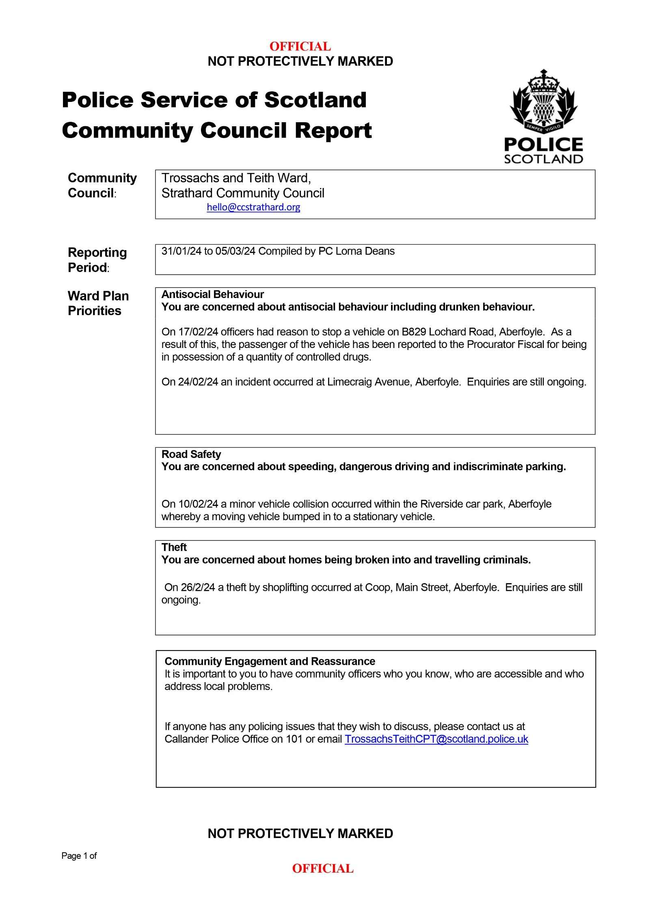


Balmaha –
- Conic Hill is currently inaccessible to visitors in both directions due to a large stand of windblown trees and a defective foot bridge. .
- Windblown trees from Storm Isha have affected hill access from Balmaha. Our contractor will begin clearing these trees tomorrow, 5th March. While this work is ongoing, you will not be able to access Conic hill from Balmaha. Please obey all onsite signage and advice from bankspersons.
- We aim to have the path from Balmaha opened by Easter 2024.
- The Loch Lomond and Trossachs National Park are currently replacing the defective footbridge on the Easten side of Conic Hill.
Garadhban -
- Harvesting to remove Phytophthera ramorum infected larch trees is now complete at Garadhban. The car park, Millburn and Craigievern Trails will be closed until Easter 2024 to allow for safe haulage of timber along the West Highland Way.
The West Highland Way and Rob Roy Way will be diverted through Drymen to avoid the active site. Please follow any diversion and advice from operators.
Loch Ard –
- The thinning operations in Loch Ard have now been completed and all trails are now open as normal. Please be aware there will be timber haulage in the area. Please obey all onsite safety signage and advice form operators.
- There are some windblown trees across forest roads within Loch Ard affecting the Lomond View and Aqueduct Loop Gravelfoyle routes. These trees will be cleared as soon as possible and routes will reopen.
Strathyre –
- Harvesting at East Strathyre is complete with timber haulage ongoing, near the Tighanes Burn Trail (blue). The trail remains open - please obey all operational and diversion signage and advice from onsite operators during this time.
- Harvesting in East Strathyre by Kingshouse continues. The Rob Roy Way will remain open but please obey any onsite signage and advice from operators.
- A new harvesting site has begun north of the Strathyre cabins near the Rob Roy Way. The Rob Roy Way will remain open. Please obey any onsite signage.
Loch Chon –
- Harvesting work on the West side of Loch Chon has been completed. There are some minor works to be carried out to clean up the site, during which time there will be limited access to this section of forest road. The diversion route will be removed and the forest road open again to visitors once this work has taken place.

Achray –
- A new harvesting site has started in a section of forest between Leannach car park and the Ben Venue hill path. Please obey onsite signage and operators instructions
Bochastle –
- Ben Ledi Hill path and Car Park are open as normal, however there is no access to Ben Ledi hill path via the Bochastle Car Park. Felling is complete in this area, with haulage ongoing. Find out more about how to protect our forest from tree disease here.
Callander –
- Coilhallan Woods car park has now been reopened. All felling required has been carried out with limited haulage still to be completed.
Braeval –
- The Rob Roy Way between Braeval and The Lodge is open, however, there will be timber haulage ongoing throughout the site for the coming weeks.
- Please be aware of timber haulage on the forest road network here and obey any on site signage and advice from operators.
Balquhidder –
- There is active timber haulage in the forest roads north of Balquhidder. Please be obey any signage and advice from operators.
The Lodge Forest Visitor Centre –
- The bridge at the Waterfall Trail is currently closed for public safety after an inspection. A new bridge is in the process of being procured. Whilst this takes place there is no access across the bridge to the wildlife hide or onto the Lime Craig trail whilst we wait for the new bridge to be installed. The public can access the hide from Braeval along the forest roads.
Three Lochs Forest Drive –
- The Three Lochs Forest Drive is currently closed to public vehicles until Spring 2024.
- Harvesting works to deal Larch trees infected with Phytophthera ramorum has been talking place. Walkers and cyclists will still be able to access the drive, but please obey any onsite signage and operators advice and be aware of timber haulage in the area. .

Sallochy Campsite –
- Sallochy campsite is currently closed to campers for the winter. The paid public car park has been reinstated until the campsite reopens in the spring.
- The campsite is due to re-open for the season on March 28th.
- The toilets are locked for the winter.
Stay the Night –
- The Stay the Night scheme for overnight motorhome parking has been extended until October 31st 2024. As such these sites will be available to use for self-contained motorhomes over the winter, with payment through Ringgo. You can find out more about the Stay the Night scheme here: Stay the Night - Forestry and Land Scotland

Upcoming Works
There are a number of Statutory Plant Health Notices that have recently been issued to sites within the Queen Elizabeth Forest Park. Harvesting works to deal with these Phytophthera ramorum infections will be taking place in the coming weeks and months.
These include:
Achray (between The Lodge and the three Lochs Forest Drive)
Routes impacted: Lime Craig Trail, The NCN7 cycle route.
Braeval
Routes impacted: Braeval Car Park, Stonefields Trail, Braeval Trail, The Rob Roy Way.
Strathyre / Loch Lubnaig
Routes impacted: A84, Forest roads
Falls of Leny
Routes impacted: A84, Forest roads.

Dates for the start of these works and details of diversions and closures will be issued in due course.

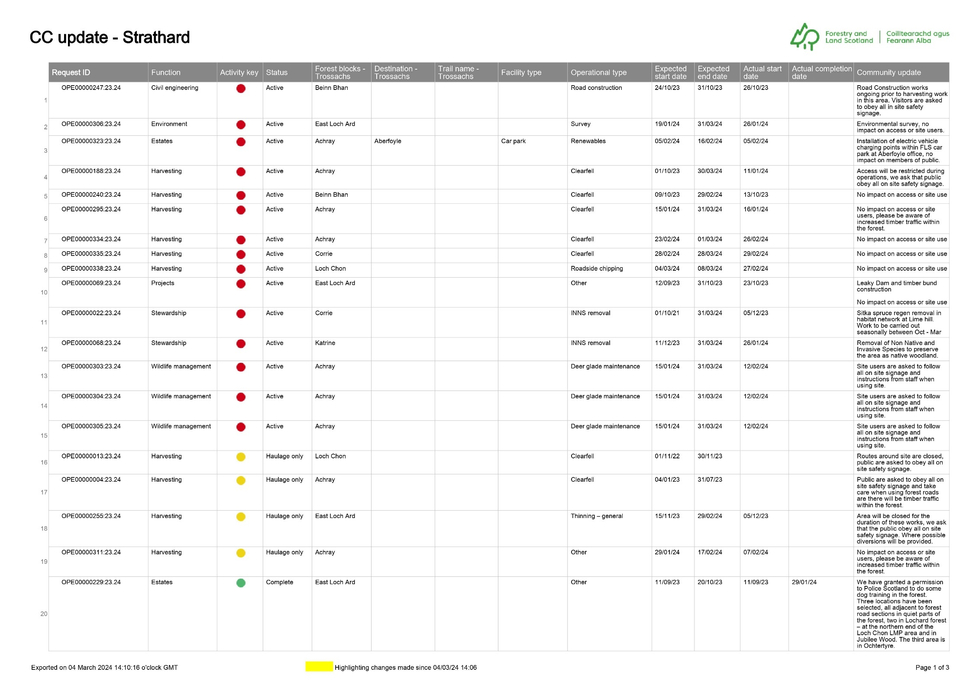
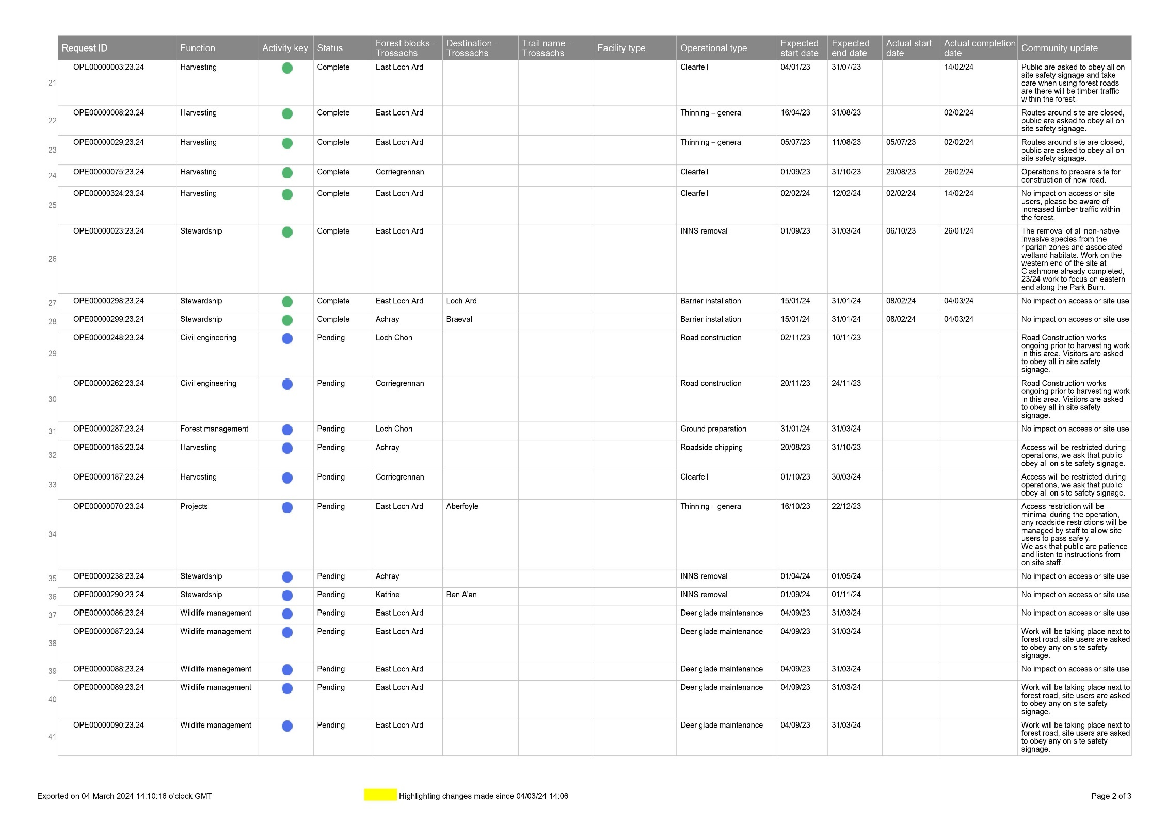
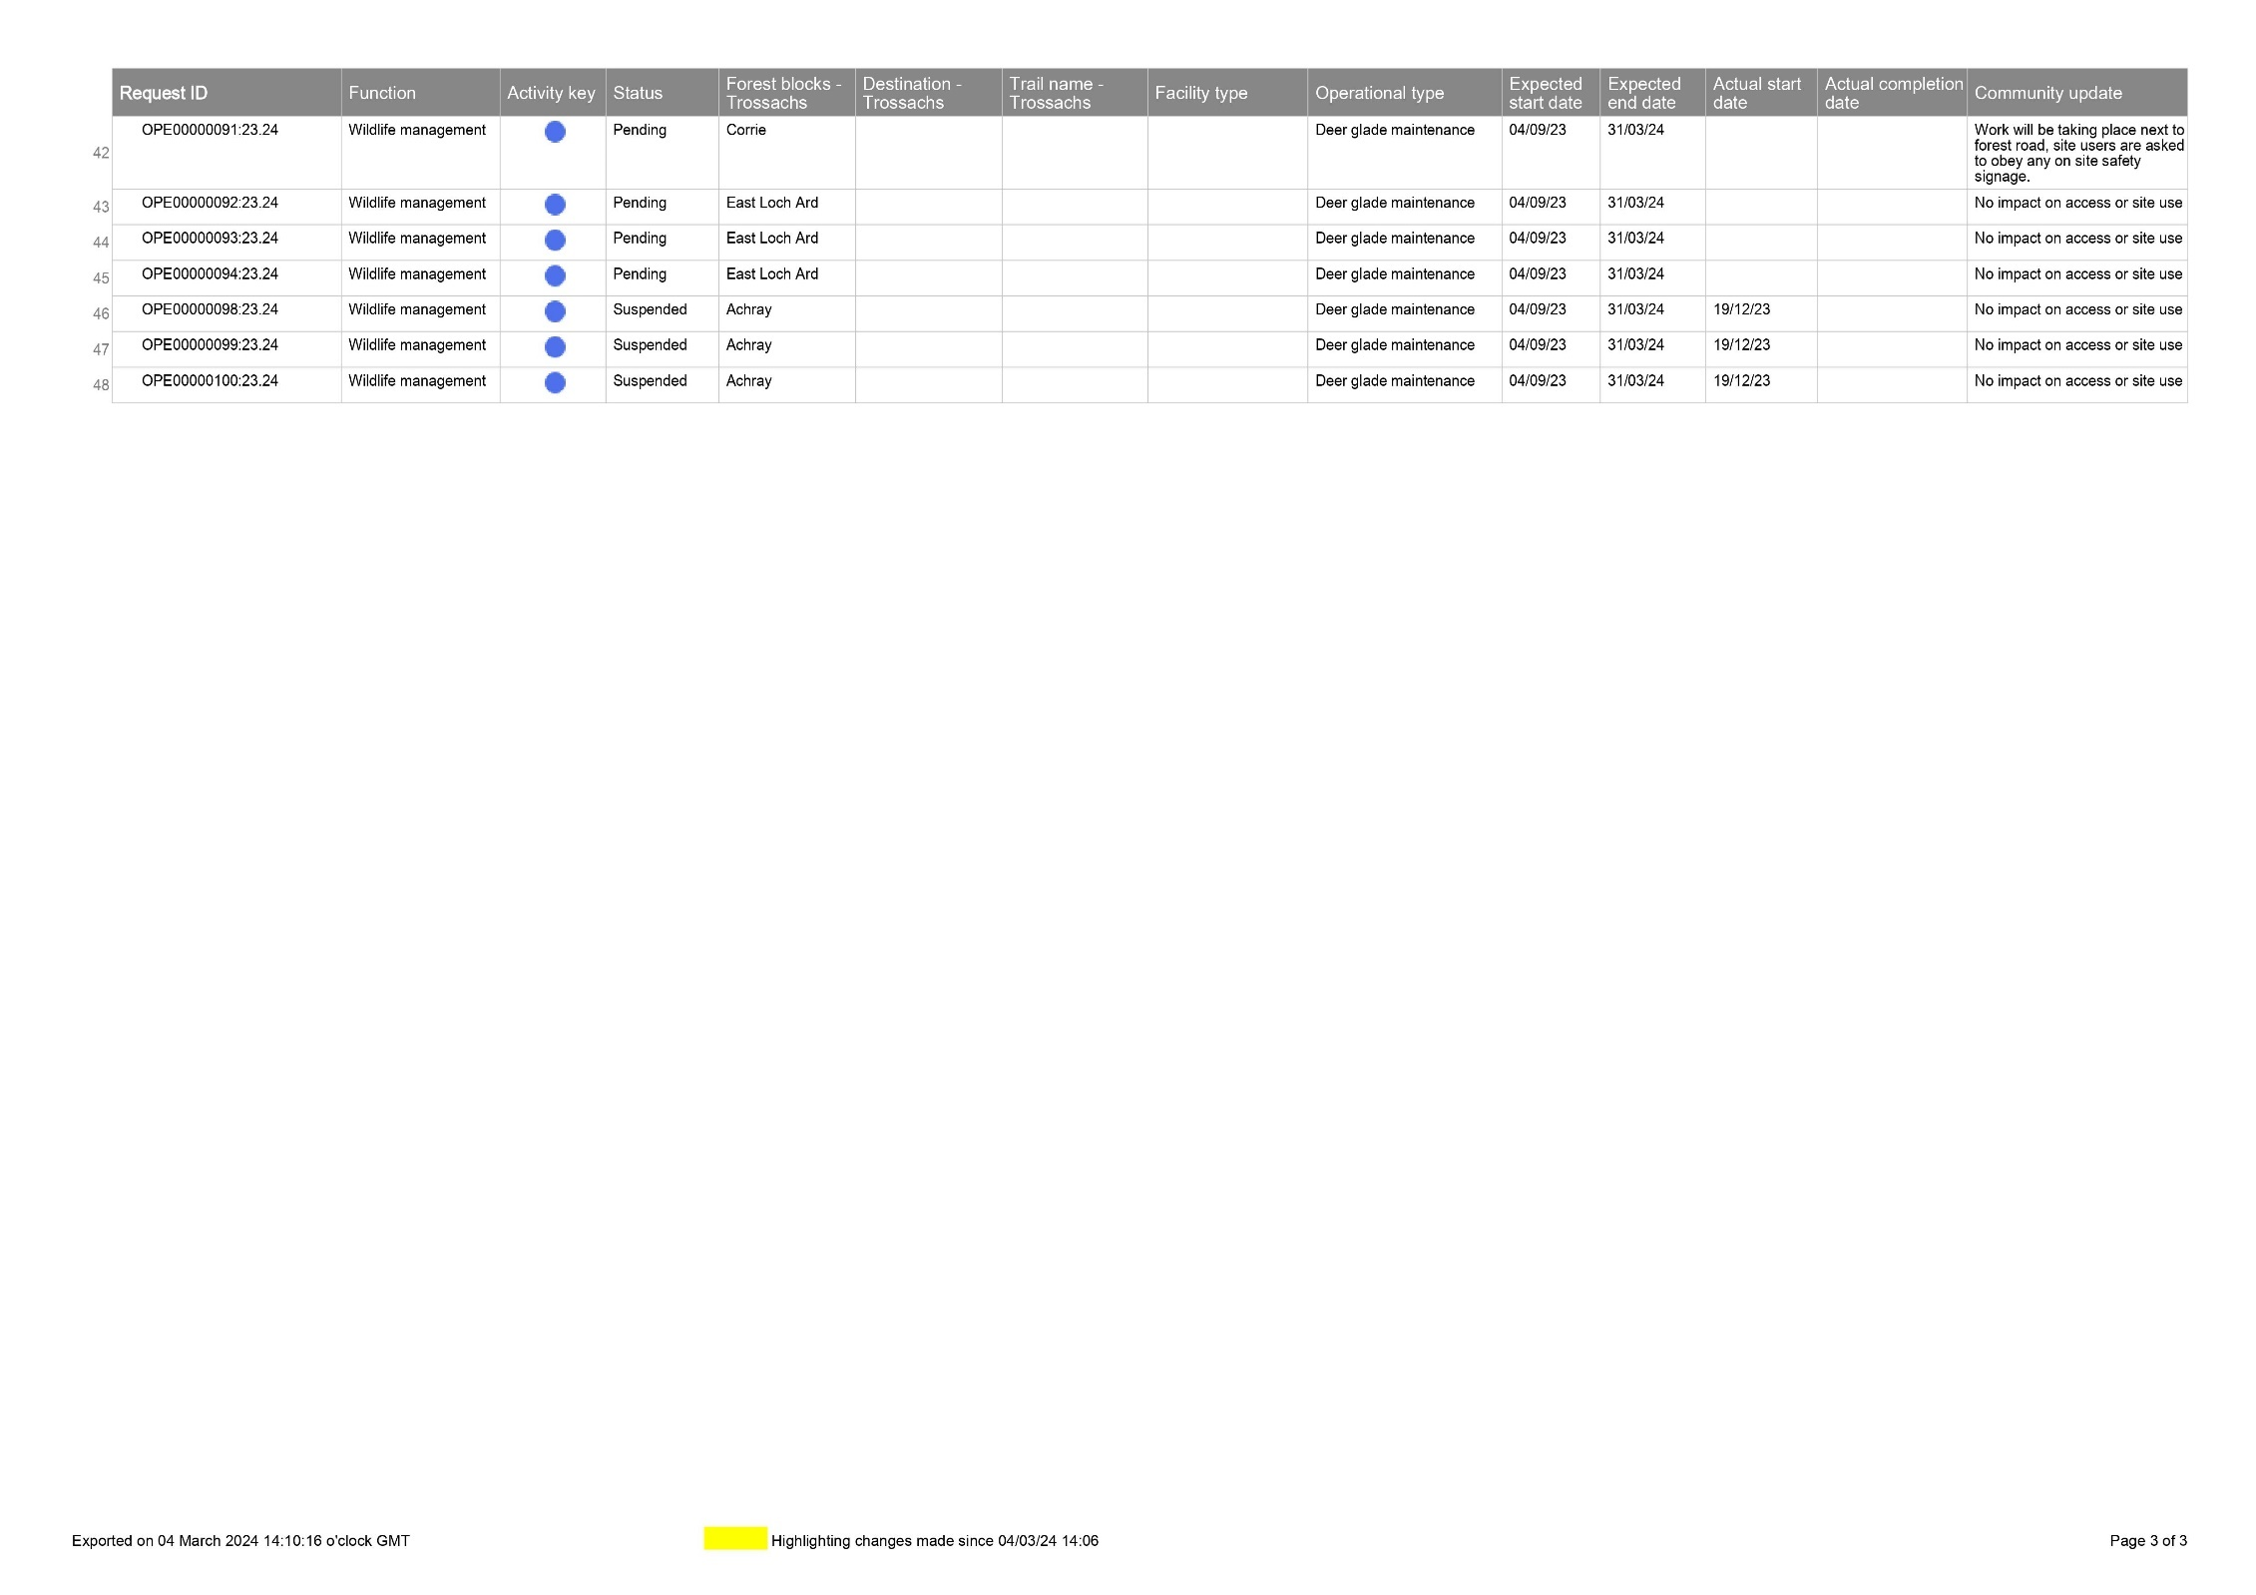
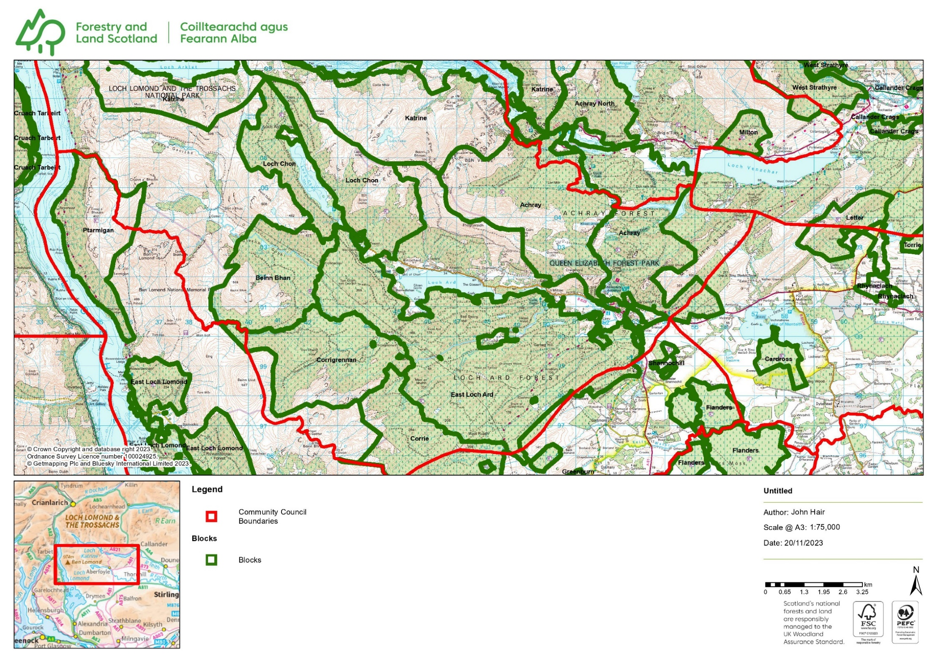

APPLICATIONS
There are no new planning applications lodged for Strathard during this period.
APPROVALS
There is only one approval noted during this period. 23/0415/NOTdate Valid 7 November 2023 Telephone 01389727721 Proposal Formation of 1x timber stacking area (30m x10m) and 2x harvesting access ramp 10mx6m and re-instatement of turning point Location Land West Of Balleich, Aberfoyle Loch Ard Forest
OVERDUE APPLICATIONS
There is currently only one overdue application for Strathard. Application Number 2023/0408/DET Development Proposed : Erection of 25 metre high telecoms mast, installation of solar array, installation of associated equipment and construction of access track Location: Meal Dubh Loch Ard.
It appears that one reason this application is overdue is down to FLS who presumably have to approve development on their land. This may be the mast earmarked to sit on the site of the old watch tower.
Some time ago when FLS notified the community and the SCC that the watch tower was deemed to be unsafe and was earmarked for demolition I made enquiries within the community on behalf of the SCC and the History Group. While there was some local interest the last time talk of demolition was raised the links were tenuous and we felt difficult to justify expensive renovation. From my recollection we agreed a small plaque identifying the site and local participation in fire watching duties was felt to be suitable.
I am sure that a plaque of this nature could be incorporated into the new site as both were/are significant for the safety of the area.
Clearly the area needs better mobile connectivity not just for emergency services but for domestic use also and the location of the 3 sites suggested as being required for line of sight connections are situated in fairly remote areas.
The SCC has already agreed in principle to the planning applications so unless new information has come to light in the interim I see no reason to object to dismantling the tower.

Weekly Planning Lists – February 2024

Applications:
No new applications this period.
Approvals:
WK 5
23/0415/NOT Officer Amanda Muller Date Valid 7 November 2023 Telephone 01389727721 Proposal Formation of 1x timber stacking area (30m x10m) and 2x harvesting access ramp 10mx6m and re-instatement of turning point Location Land West Of Balleich, Aberfoyle Loch Ard Forest Applicant Mr Colin Peacock Forestry and Land Scotland 5 Sisters House 5 Sisters Business Park West Calder EH55 8PN Agent Application Type Prior Notification National Park Ward 2 Breadalbane and The Trossachs Community Council Area Strathard CC National Grid Co-ordinates 251149 E 699609 N Date Decision Issued 31 January 2024 Decision Approve
Withdrawals:
None
Refusals:
None
Enforcement Matters:

None

Appeals:

None

Overdue Applications:

Application Number 2023/0408/DET Development Proposed : Erection of 25 metre high telecoms mast, installation of solar array, installation of associated equipment and construction of access track Location: Meal Dubh Loch Ard Stirling Stirlingshire FK8 3TS Applicant: Cornerstone Agent’s Name: Chris Weir Agent’s Company Name: WHP Telecoms Ltd Agent’s Address: 401 Faraday Street Risley Warrington WA3 6GA Date Application Valid: 2 November 2023 Date of expiry of period for representations: 19 December 2023

Dear Fellow Community Councillors,

I am contacting you on behalf of Gartmore Community Trust, which shares a boundary with your Community Council or Community Trust. We have been working on a Local Place Plan for our Community Council area, involving community engagement over the last few months.
We have now prepared a draft Local Place Plan. It has just been published online for public consultation through this link: Gartmore LPP 2024-34 until 02/04/2024. If you have contacts who might be interested, please do share that link with them.
We are legally required to send each adjoining Community Council the following information, to comply with Section 4 of the Town and Country Planning (Local Place Plans) (Scotland) Regulations 2021:
1. Proposed Local Place Plan
The proposed Local Place Plan is too large a document to be send via email, you can download from Gartmore LPP 2024-34.
2. Brief description of the content and purpose of the proposed Local Place Plan
The Plan covers the Gartmore Community Council area, which stretches from just south of Braeval in the north, to 2km south-west from Dalmary. In the east it extends westwards from Gartrenich Moss into the hills to the south-west of Gartmore Village. A map of the Community Council area can be seen near the start of the Plan.
The primary purpose of the Plan is to provide an up-to-date statement of current issues we face and our aspirations for the ten years, to help public bodies, landowners, businesses and funders consider how they can best support positive change in the area.
There are 41 strategic priorities covering seven Themes in the Gartmore Place Plan. These Themes are as follows:
1. Outdoor Access and Land Management
2. Reaching Net-Zero
3. Community Spaces and Facilities
4. Village Realm
5. Transport, Roads and Parking
6. Economy and Housing
7. Community Resilience

3. Information as to how and to whom any representations on the content of the proposed Local Place Plan should be made and the date by which they should be made

If you have comments on the attached proposed Local Place Plan, please email them to Kelly Clapperton at kaclappertonbates17@gmail.com
• The deadline for comments is 02/04/2024.
• If you need more time to respond, please let me know.

The above information comprises the ‘information notice’ to which the Regulations refer.

Please let me know if you have any queries.

Regards,

pp. Kelly Clapperton
Katie Goldie
Chair of Gartmore Community Trust

Kelly Clapperton
Community Planning and Development
Thursdays and Fridays, 9am-5pm
Phone: 07809429235.
Website: Kelly Clapperton Consultancy


Dear Sir/Madam

Re: Forest Management carried out by The Royal Society for the Protection of Birds (RSPB) SA-FM/COC-005221

In April 2024 we will carry out a Forest Stewardship Council® (FSC®) Forest Management assessment of forest management by The Royal Society for the Protection of Birds (RSPB) in UNITED KINGDOM. They will be assessed against the requirements of the FSC-STD-GBR-03-2017 V 1-0 EN; UKWAS 4.0 (2018)
A full list of the forest / woodland locations within their Group Scheme is enclosed with this consultation document and feedback regarding management practices at any of these sites is welcome.
We would welcome any comments you have on;
- forest management carried out by The Royal Society for the Protection of Birds (RSPB) and/or sites within their Group Scheme and/or
- the FSC Standard being used (you can view this standard at www.soilassociation.org/forestry / https://ic.fsc.org/en/certification/national-standards / http://ukwas.org.uk/ )

To comment, please complete our online stakeholder feedback form, using the link below:
www.soilassociation.org/stakeholderconsultation/
The deadline for comments is 05-Apr-2024.
If your comments are site specific, please state very clearly which site they refer to.
Thank you in advance for your time.
Yours faithfully

Valentins Kuksinovs
Certification Manager
+44 (0)117 9142435
forestryconsultation@soilassociation.org
www.soilassociation.org/forestry

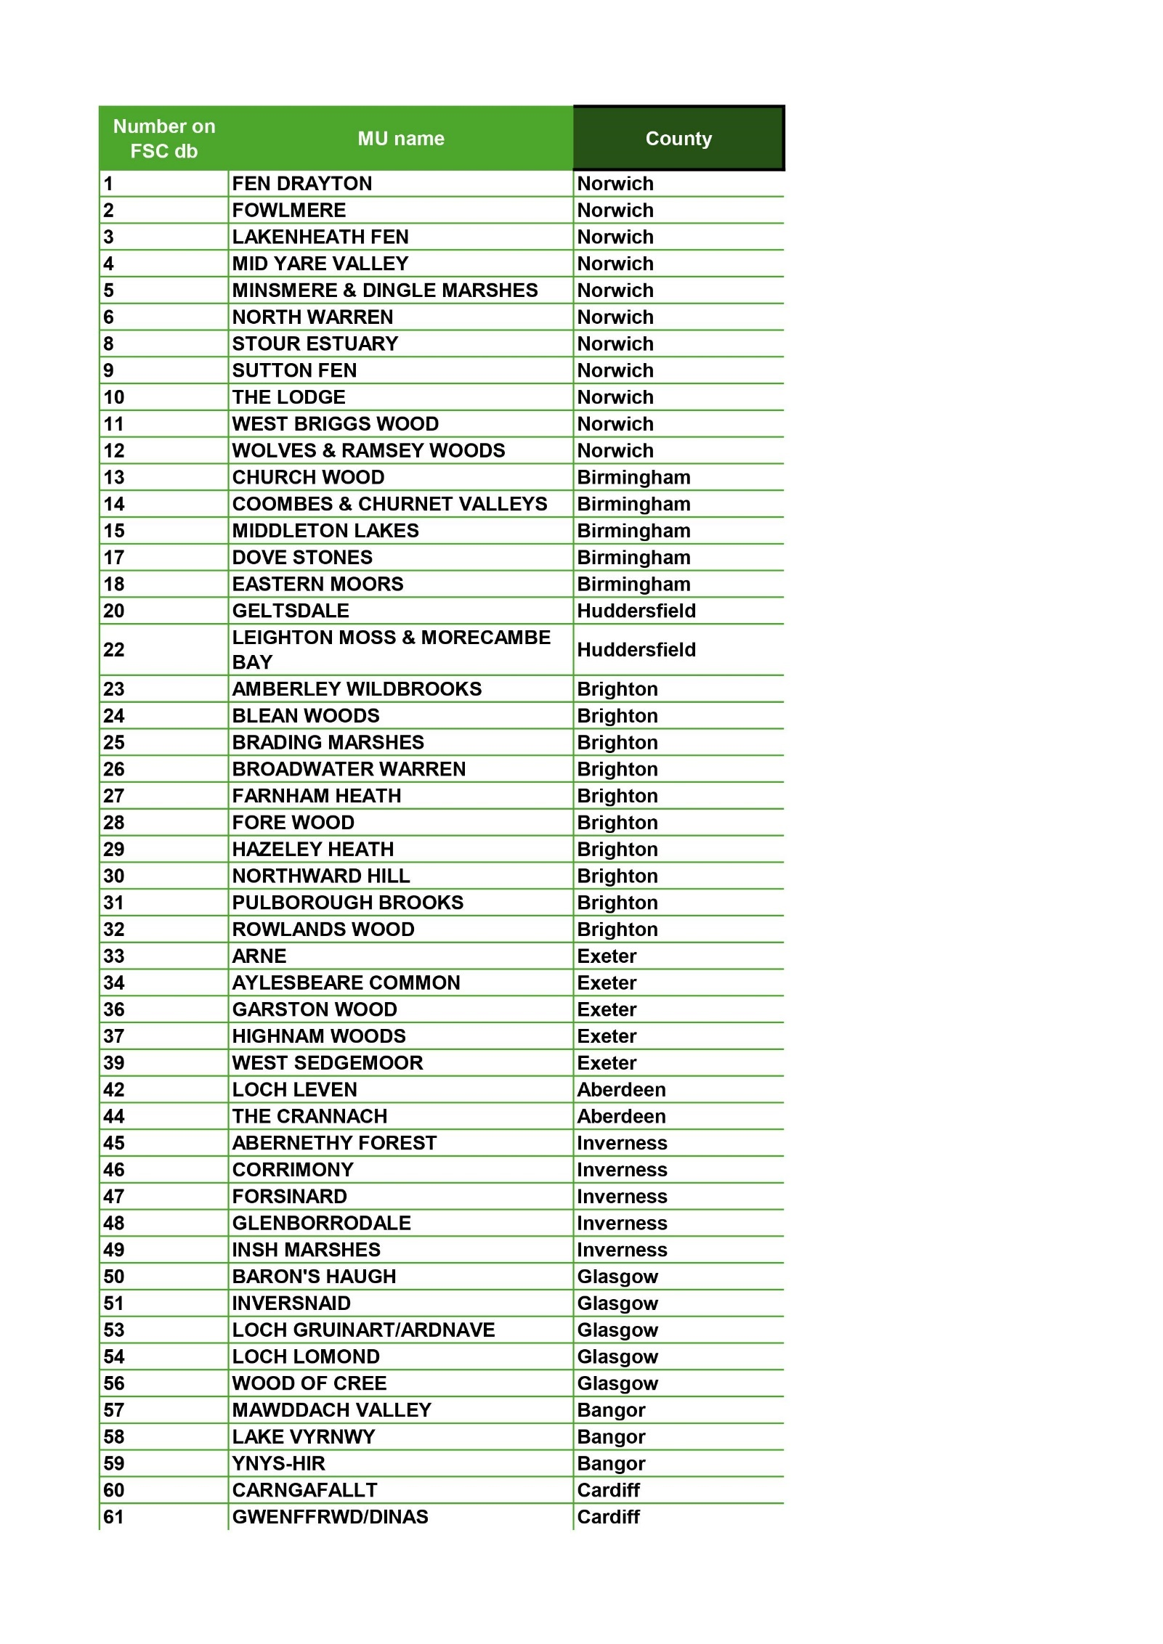

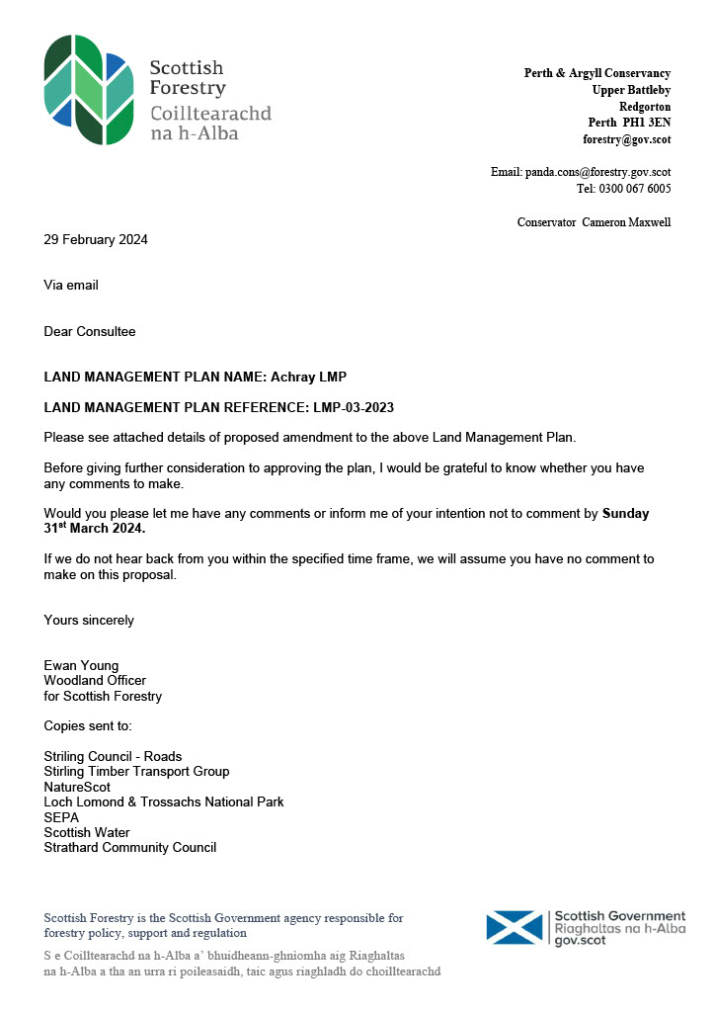

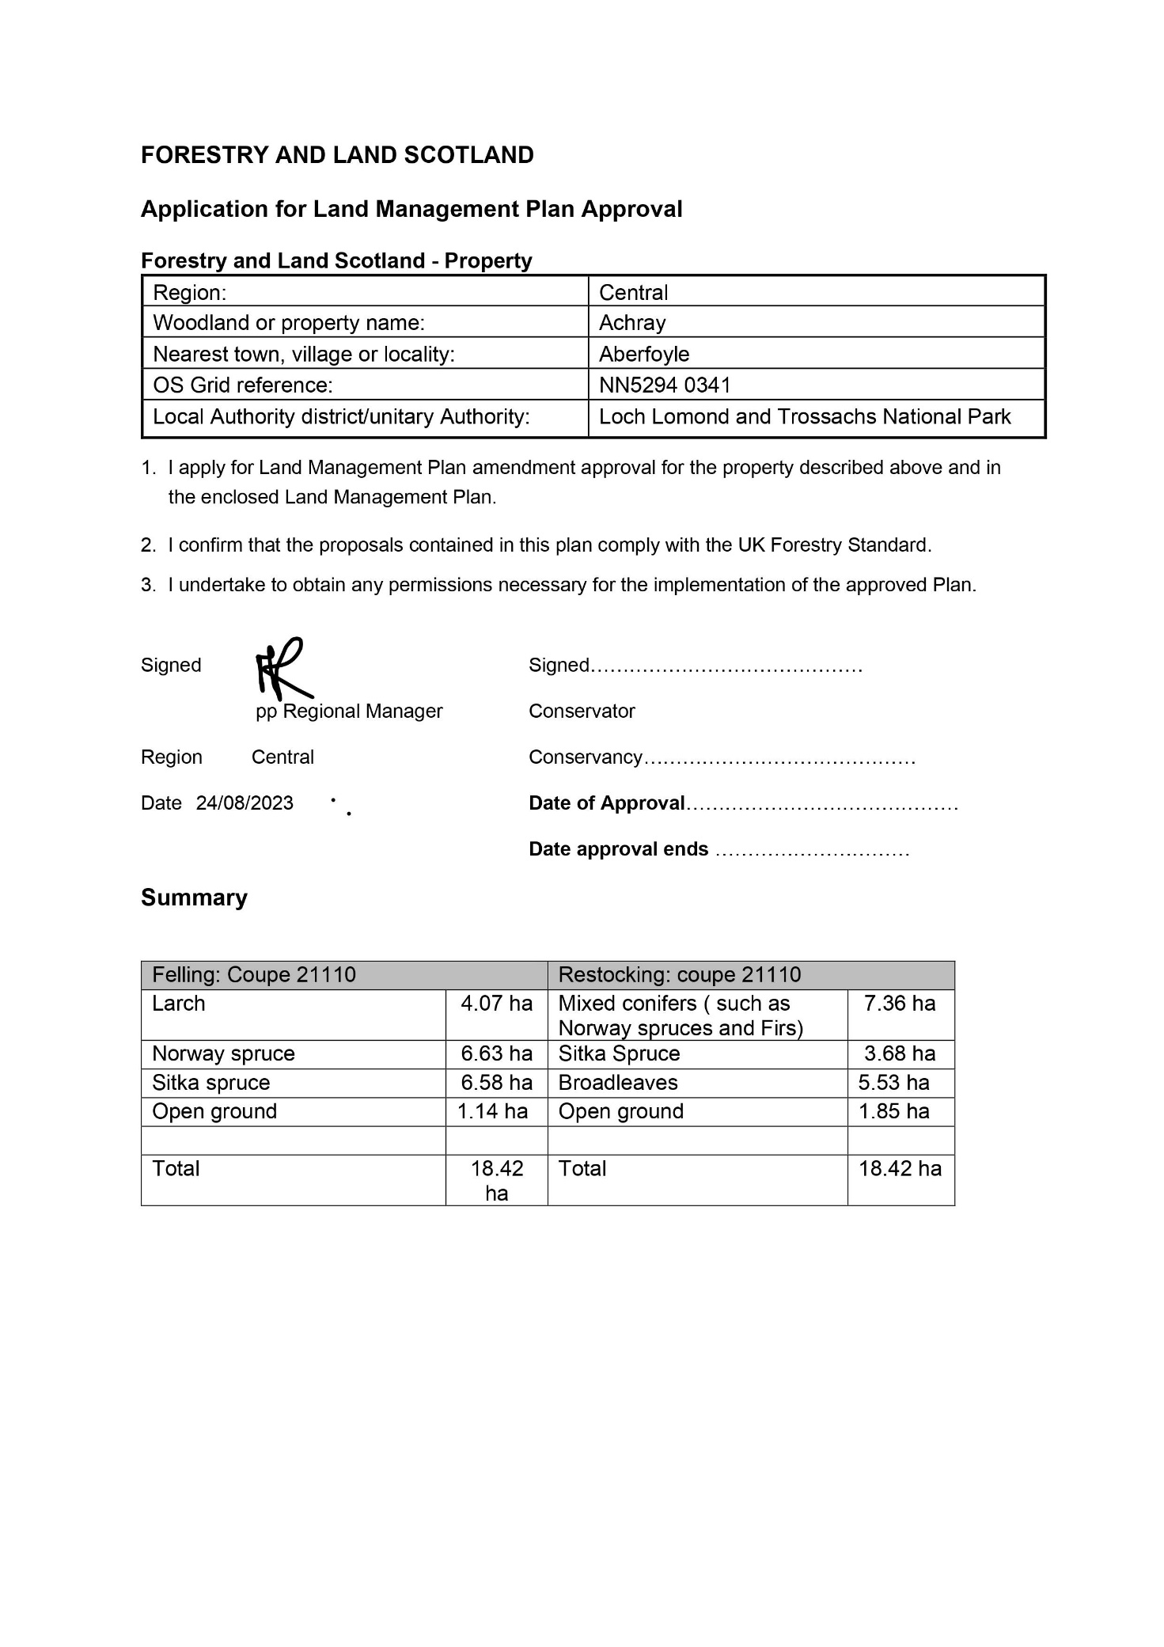

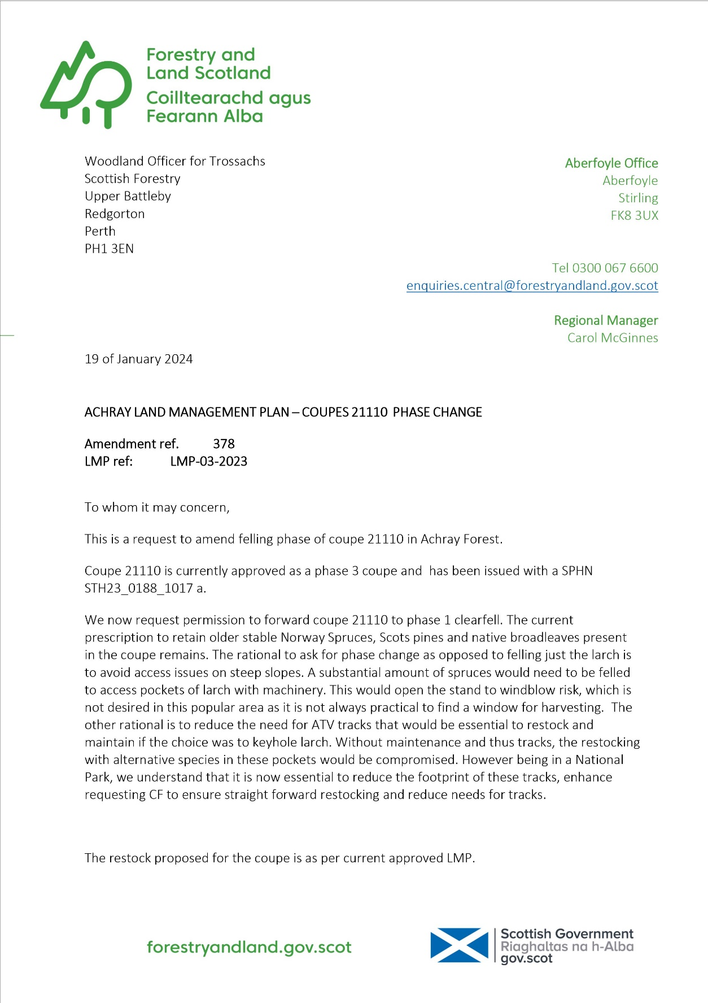

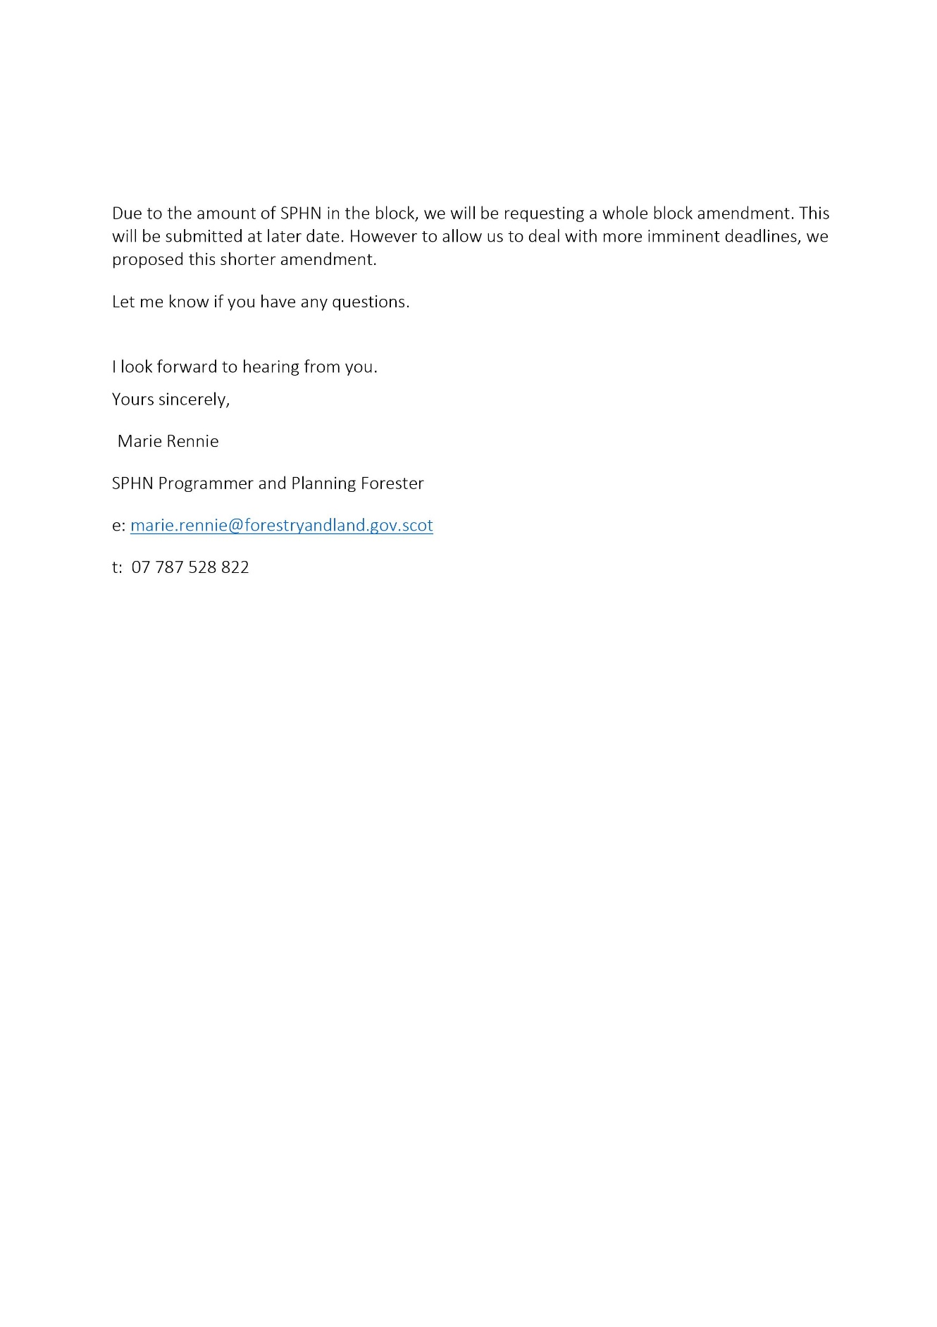
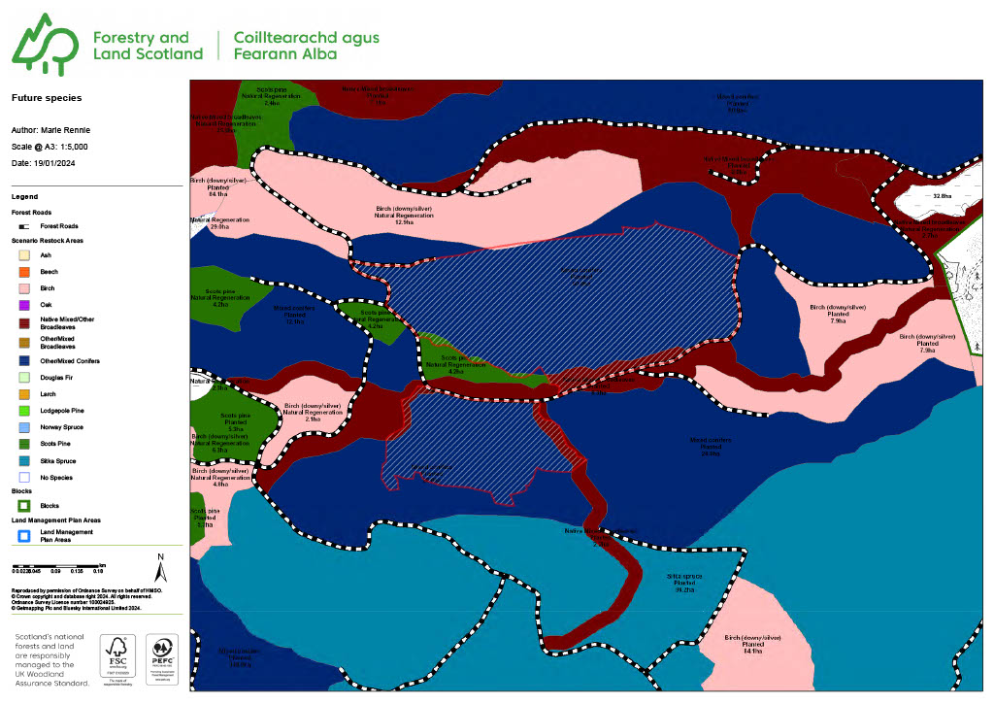
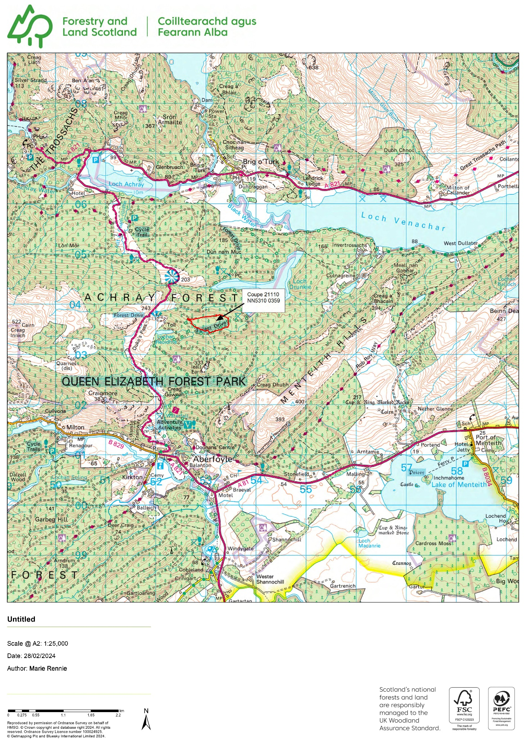
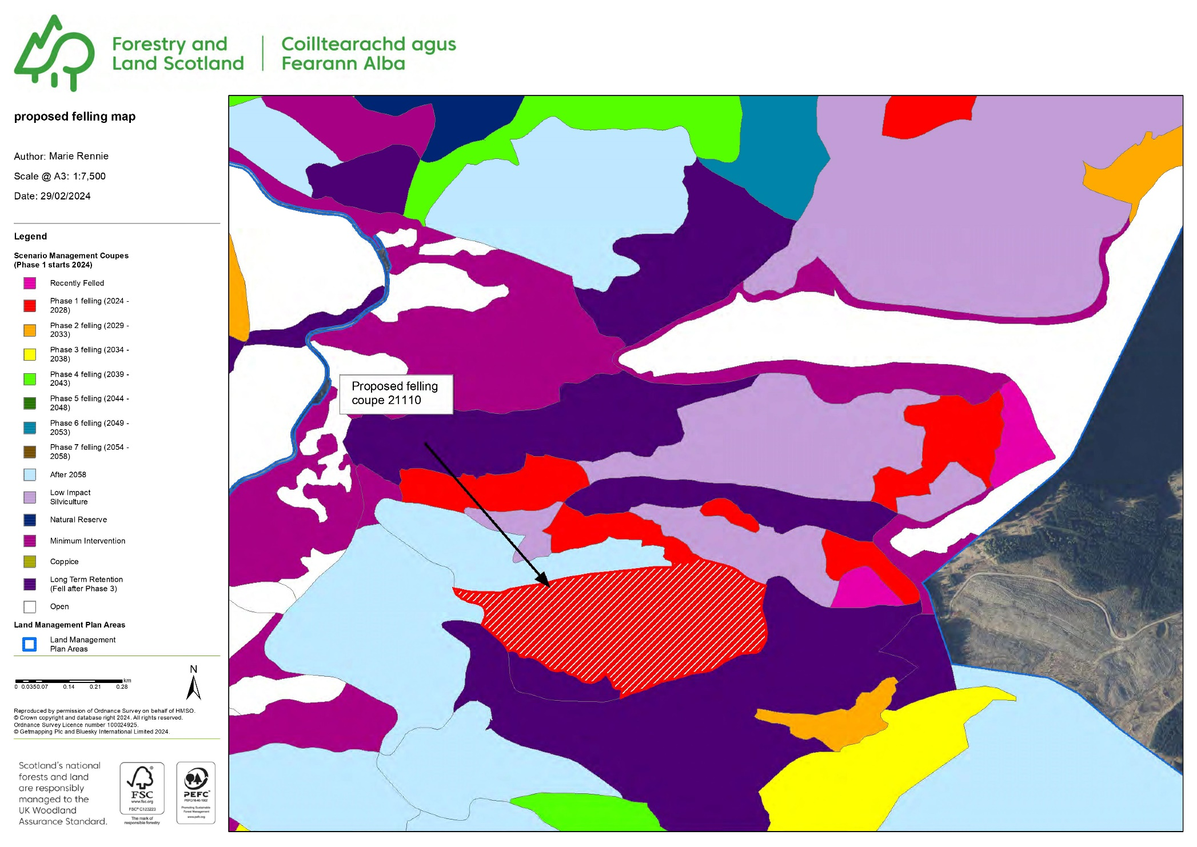
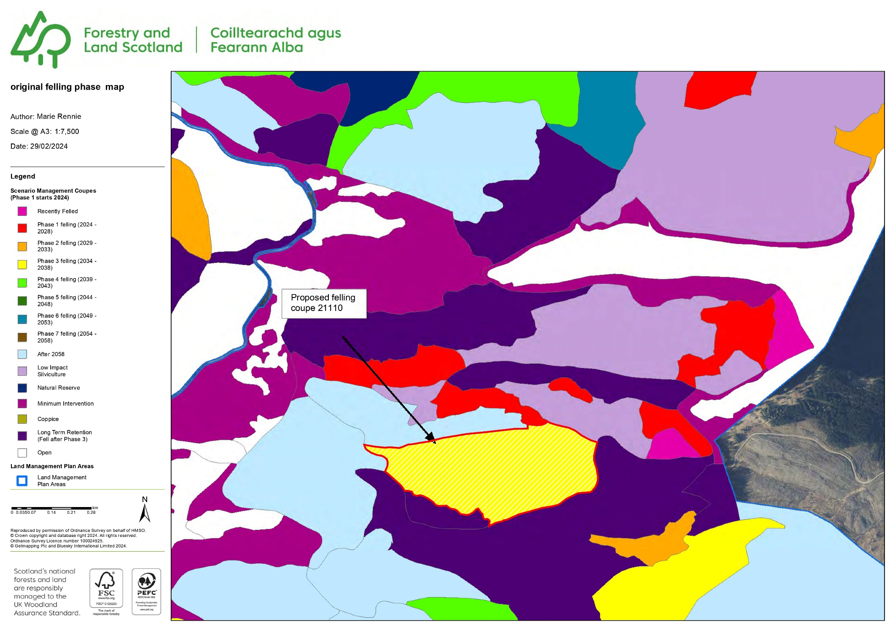
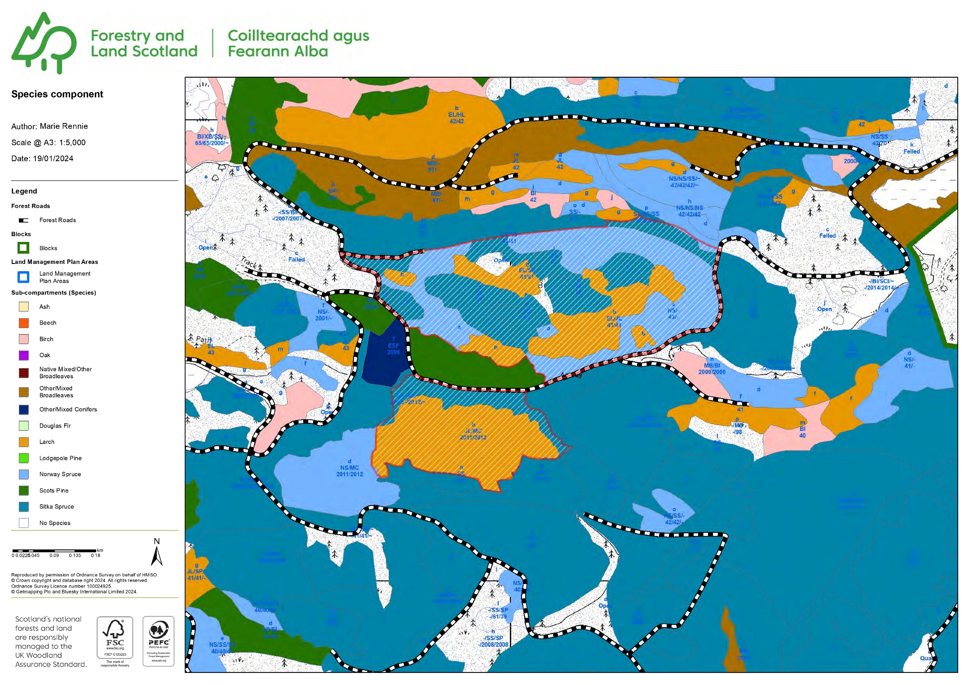
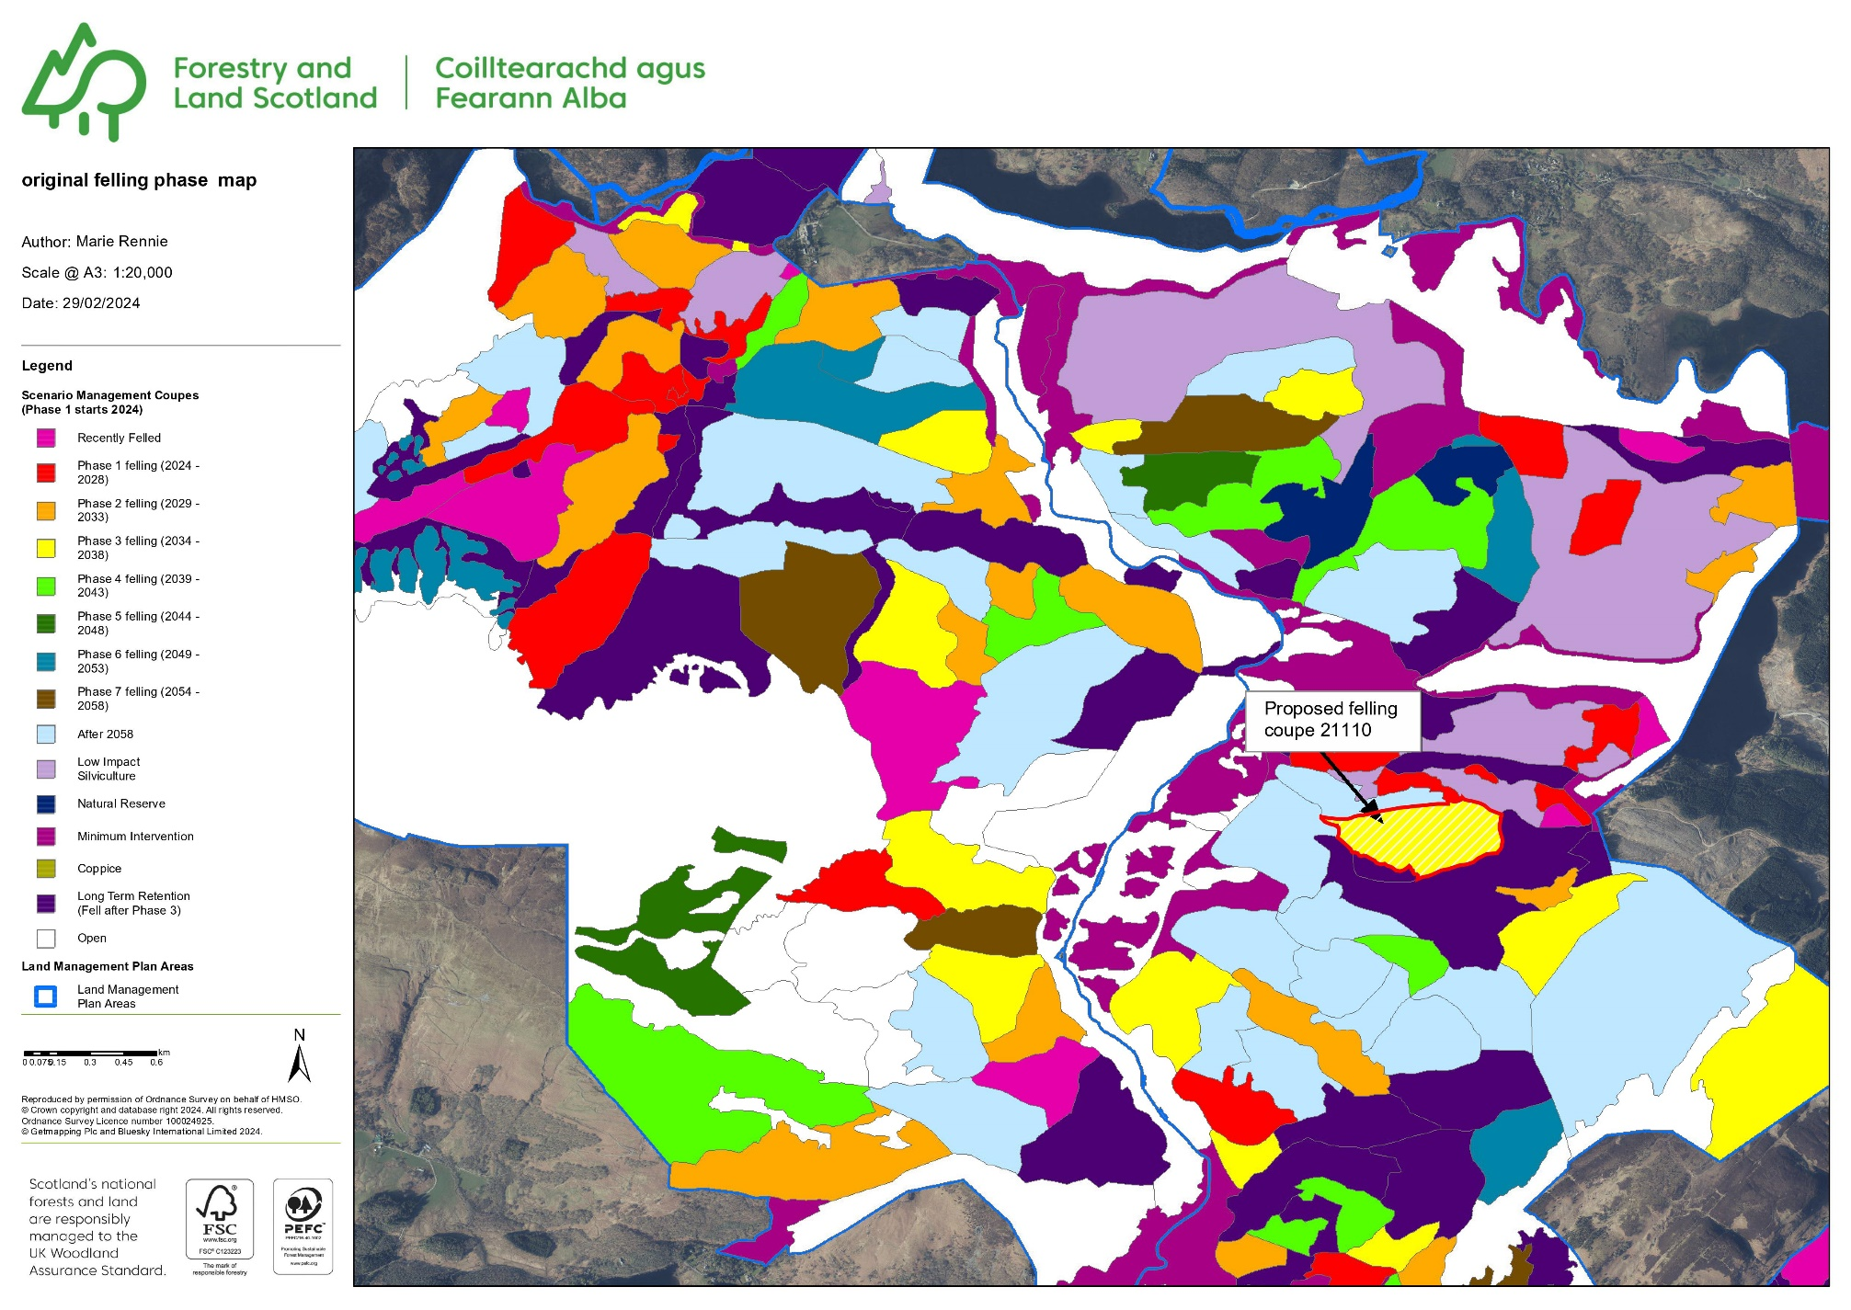

The COUNCIL made The Stirling Council (Allanvale Road / Union Street, Bridge of Allan) (Temporary Suspension of Parking) Order 2024 under the Road Traffic Regulation Act 1984 (as amended) on 1-3-24.

This Order will suspend the parking on:

Allanvale Road On its west side from a point 55 metres north-west of its junction with Union Street in a south-easterly direction for a distance of 155 metres or thereby; and,

Allanvale Road On its east side from its junction with Union Street in a north-westerly direction for a distance of 55 metres or thereby; and,

Allanvale Road On its east side from its junction with Union Street in a south-easterly direction for a distance of 65 metres or thereby; and,

Union Street On both sides of the road from its junction with Allanvale Road to its junction Keir Street from 0800 hours until 1800 hours on 24-3-24 to facilitate public utility works.

A COPY of the Order can be provided by e-mailing traffic@stirling.gov.uk.

www.stirling.gov.uk or www.tellmescotland.gov.uk

The COUNCIL made The Stirling Council (B8034, Port of Menteith - Arnprior) (Temporary Prohibition of Traffic – No 3) Order 2024 under the Road Traffic Regulation Act 1984 (as amended) on 1-3-24.

This Order will close:

B8034 For its entire length on 25-3-24 to facilitate public utility works.

Emergency service access will be maintained

Alternative Routes: via A811, B822, A873, A81 and vice versa

A COPY of the Order can be provided by e-mailing traffic@stirling.gov.uk.

www.stirling.gov.uk or www.tellmescotland.gov.uk

